DNA Sequence Classification Using Bi-LSTM-CNN
Akshay Chatterjee¹

2 Department of Computer Science and Engineering, St Thomas‘ College of Engineering and Technology, Kolkata 700 023, India
akshay.chatterjee2015vit@gmail.com
Abstract. DNA sequence classification is a remarkable work in Computational Bio-Technology field. DNA differs for human and other kinds of speices. To identify the speices DNA is an important and unique identity. But still we can improve the accuracy of the classification of DNA.The proposed methodology has selected a set of DNA sequences which carry more information about the speices.That sequence has been classified in unsupervised manner through a network that consists of both Bidirectional Long Short Term Memory and Convolutional Neural Network. Then we have compared with the previous methods and have got better log-loss for our proposed methodology.
Keywords: DNA Sequence, Classification, LSTM, CNN
1 Introduction
Long Short Term Memory(LSTM) is an important sequence classification method. It is a type of reccurent neural network capable of creating virtual memory similar to human being as of remembering things. It takes a sequence as an input and classifies the type of the sequence. It checks the sequence only in one direction. But bi-directional LSTM(BI-LSTM) goes through a sequence in both directions. Convolutinal neural network(CNN) is generally known for imagery analysis. But we can also use it to train a network for sequence classification. In our work, we have discussed a new methodology for sequence classification. The proposed methodology contains a network with both BI-LSTM and CNN. We have got a better log loss curve for our proposed methodology than the previous networks. Our objective is to classify a DNA Sequence accurately into its corresponding classes using the previous as well as our proposed method and compare among them. LSTM in its core, preserves information from inputs that has already passed through it using the hidden state.Unidirectional LSTM only preserves information of the past because the only inputs it has seen are from the past.Using bidirectional will run your inputs in two ways, one from past to future and one from future to past and what differs this approach from unidirectional is that in the LSTM that runs backwards you preserve information from the future and using the two hidden states combined you are able in any point in time to preserve information from both past and future.

  - Related Work
Past work has highlighted the application deep learning in different domain. Gene sequence identification is one of the upcoming problem where LSTM is being used. Sundermeyer et.al[1] has proposed LSTM neural networks for language modeling. Gers et al have proposed a prediction model using LSTM which is new idea for the classification scheme. This concept has been explored and upgraded in further research [3]. Graves et.al [4] has suggested a hybrid speech recognition with deep bidirectional LSTM. Greff et al.[5] "LSTM have introduced a very novel technique for search space odyssey using LSTM. The concept of LSTM has highlighted in TTS synthesis with bidirectional LSTM based recurrent neural networks by Fan, Yuchen, et al [6]. Huang et.al [7] Bidirectional LSTM-CRF models for sequence tagging which is also a novel idea in the domain of deep learning. The notion and application of deep learning in bioinformatics has been surveyed and highlighted by researchers in the past work [8-9]. Pita et.al [10] al have proposed Genomic and biological diversity of the African cassava geminiviruses. Lipton et al [11] has propounded learning with diagnose through LSTM recurrent neural networks. Quang et.al [12] have presented hybrid convolution and recurrent deep neural network for quantifying the function of DNA sequences. Williams et.al [13] have highlighted efficient approach on gradient-based algorithm for on-line training of recurrent network trajectories. Mao et.al [14] has explored deep captioning with multimodal recurrent neural networks (m-rnn). Graves et al. [15] has propounded speech recognition with deep recurrent neural networks.
2 Proposed Methodology
We have used online dataset of DNA Sequence from fruitfly.org. The dataset contains sequence of the DNA and the speices type. Then we have built a sequential model. The first layer of the model is treated as BI-LSTM which contains 20 neurons. Then the feedback from the layer 1 is passed to the CNN layer of the model. The CNN model has used Rectified Linear Unit activation layer. After that we have done 1D Maxpooling with pool size 2 and passed through a dense layer at last. The activation function is sigmoid.

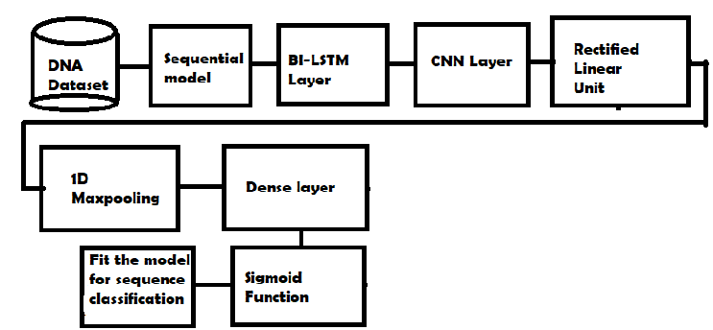

- Schematic block diagram for Emotion Recognition System

3. Experimental Result

We have classified DNA sequences using our proposed methodology and got better result than existing networks. We have plotted the log-loss curve for the three kinds of networks: LSTM forward, LSTM backward, BI-LSTM-CNN. We have plotted the log-loss curve because it’s a better metric than accuracy. Lesser the log-loss better the accuracy of classification.

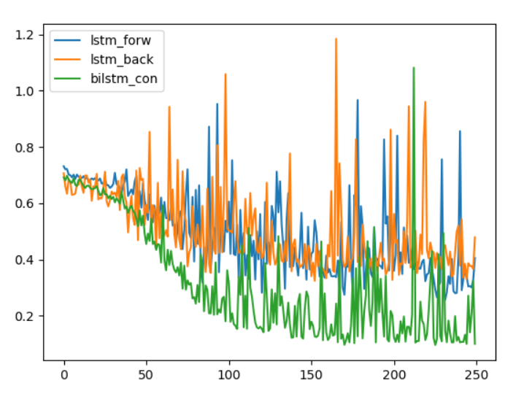
Fig 2. Log loss curve comparison

In Fig 2. Log Loss curve indicating the best result is supplied by BI-LSTM-CNN among the three.
Log loss curve denotes whether the prediction input is in the probability of 0 and 1. The aim is to minimize log loss. A log loss value of 0 is a best prediction. In Fig. 2, X-axis denotes predicted probability and Y-axis denotes Log loss.

Table 1. Classification Accuracy (in %) For proposed work

Classific Scheme | Human Being | Monkey | Dog | Bird
BI-LSTM | 91.5 | 92.4 | 93.7 | 91.9
LSTM | 81 | 80.6 | 80.4 | 80.3
CNN | 90.4 | 90.3 | 91.6 | 90.7
BI-LSTM-CNN  ( proposed method) | 96 | 95.3 | 92.6 | 94.9

LSTM checks the sequence and compares the sequence in one direction with the trained data.
Where as BI-LSTM compares it in both directions i.e. compares future once and then past data.
CNN divides the sequence in layers and test it with the fitted data. Our model is a sequential model of all these methods and giving better accuracy in all four speices of prediction.

4. Conclusion

Our proposed method could classify the DNA sequences more precisely into its corresponding speices categories. This can be used in various applications such as discriminating a human from other speices and more. In future it can be extended with a benchmark data. We can also use the same method for DNA fingerprinting. It is a remarkable work carried out in the field of computational Bio-Technology. The work will be also extended for the cancer detection by DNA in human beings.

References

- Sundermeyer, Martin, Ralf Schlüter, and Hermann Ney. "LSTM neural networks for language modeling." Thirteenth annual conference of the international speech communication association. 2012.
- Gers, Felix A., Jürgen Schmidhuber, and Fred Cummins. "Learning to forget: Continual prediction with LSTM." (1999): 850-855.
- Graves, Alex, and Jürgen Schmidhuber. "Framewise phoneme classification with bidirectional LSTM and other neural network architectures." Neural Networks 18.5-6 (2005): 602-610.
- Graves, Alex, Navdeep Jaitly, and Abdel-rahman Mohamed. "Hybrid speech recognition with deep bidirectional LSTM." Automatic Speech Recognition and Understanding (ASRU), 2013 IEEE Workshop on. IEEE, 2013.
- Greff, Klaus, et al. "LSTM: A search space odyssey." IEEE transactions on neural networks and learning systems 28.10 (2017): 2222-2232.
- Fan, Yuchen, et al. "TTS synthesis with bidirectional LSTM based recurrent neural networks." Fifteenth Annual Conference of the International Speech Communication Association. 2014.
- Huang, Zhiheng, Wei Xu, and Kai Yu. "Bidirectional LSTM-CRF models for sequence tagging." arXiv preprint arXiv:1508.01991 (2015).
- Min, Seonwoo, Byunghan Lee, and Sungroh Yoon. "Deep learning in bioinformatics." Briefings in bioinformatics 18.5 (2017): 851-869.
- LeCun, Yann, Yoshua Bengio, and Geoffrey Hinton. "Deep learning." nature 521.7553 (2015): 436.
- Pita, J. S., et al. "Genomic and biological diversity of the African cassava geminiviruses." Euphytica 120.1 (2001): 115.
- Lipton, Zachary C., et al. "Learning to diagnose with LSTM recurrent neural networks." arXiv preprint arXiv:1511.03677(2015).
- Quang, Daniel, and Xiaohui Xie. "DanQ: a hybrid convolutional and recurrent deep neural network for quantifying the function of DNA sequences." Nucleic acids research 44.11 (2016): e107-e107.
- Williams, Ronald J., and Jing Peng. "An efficient gradient-based algorithm for on-line training of recurrent network trajectories." Neural computation 2.4 (1990): 490-501.
- Mao, Junhua, et al. "Deep captioning with multimodal recurrent neural networks (m-rnn)." arXiv preprint arXiv:1412.6632 (2014).
- Graves, Alex, Abdel-rahman Mohamed, and Geoffrey Hinton. "Speech recognition with deep recurrent neural networks." Acoustics, speech and signal processing (icassp), 2013 ieee international conference on. IEEE, 2013.

